**PRESET**

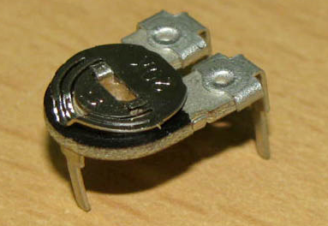

A preset is a three legged electronic component which can be made to offer varying resistance in a circuit. The resistance is varied by adjusting the rotary control over it. The adjustment can be done by using a small screw driver or a similar tool. The resistance does not vary linearly but rather varies in exponential or logarithmic manner. Such variable resistors are commonly used for adjusting sensitivity along with a sensor.

The variable resistance is obtained across the single terminal at front and one of the two other terminals. The two legs at back offer fixed resistance which is divided by the front leg. So whenever only the back terminals are used, a preset acts as a fixed resistor. Presets are specified by their fixed value resistance.

**Pin Diagram:**

